ST. XAVIER’S COLLEGE

**(Affiliated to Tribhuvan University)**

**Maitighar, Kathmandu**



**Computer graphics**

**Lab Assignment #7**

**Reflection of image about origin,X-axis and Y-axis**

**SUBMITTED BY:**

**Biraj Poudyal**

**013BSCCSIT015**

**SUBMITTED TO**

|  |  |
| --- | --- |
| **Er.Anil Sah**  **( Lecturer )** |  |
| **Department of Computer Science** | |

Submission Date: August 25th 2015

**SOURCE CODE:**

//---------------------------------------------------------------------------

#include <vcl\vcl.h>

#pragma hdrstop

#include "Unit1.h"

//---------------------------------------------------------------------------

#pragma resource "*.dfm"

TForm1 *Form1;

int x,y,a,b,i,j;

//---------------------------------------------------------------------------

__fastcall TForm1::TForm1(TComponent* Owner)

: TForm(Owner)

{

}

//---------------------------------------------------------------------------

void __fastcall TForm1::Button1Click(TObject *Sender)

{

x=Image1->Height;

y=Image1->Width;

for (i=0;i<=x;i++)

{

for (j=0;j<=y;j++)

{

a=i;

b=-j;

b=b+y;

Image2->Canvas->Pixels[a][b]=Image1->Canvas->Pixels[i][j];

}

}

}

//---------------------------------------------------------------------------

void __fastcall TForm1::Button2Click(TObject *Sender)

{

x=Image1->Height;

y=Image1->Width;

for (i=0;i<=x;i++)

{

for (j=0;j<=y;j++)

{

a=-i;

b=j;

a=a+x;

Image2->Canvas->Pixels[a][b]=Image1->Canvas->Pixels[i][j];

}

}

}

//---------------------------------------------------------------------------

void __fastcall TForm1::Button3Click(TObject *Sender)

{

x=Image1->Height;

y=Image1->Width;

for (i=0;i<=x;i++)

{

for (j=0;j<=y;j++)

{

a=-i;

b=-j;

a=a+x;

b=b+y;

Image2->Canvas->Pixels[a][b]=Image1->Canvas->Pixels[i][j];

}

}

}

//------------------------------------------------------

**OUTPUT:**

**Reflection about origin:**

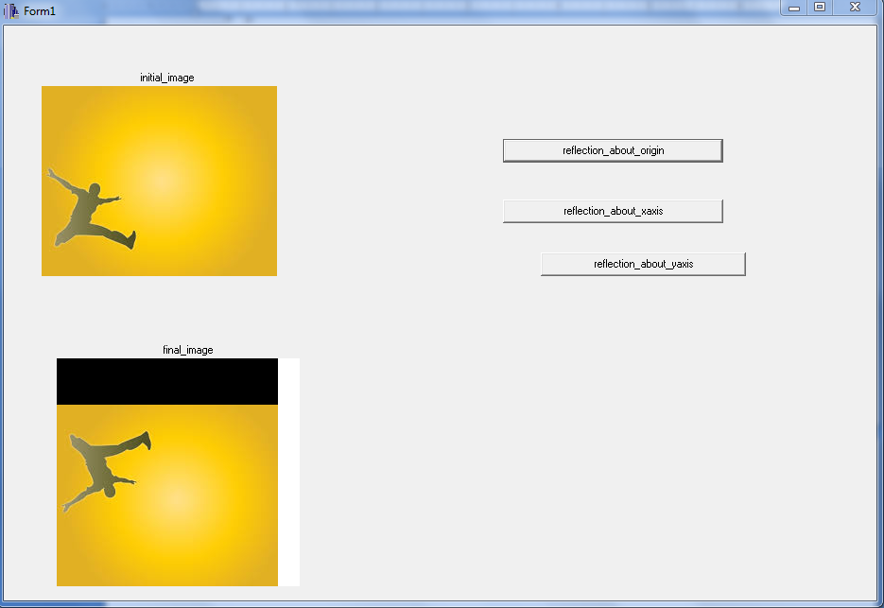

**Reflection about X-axis:** 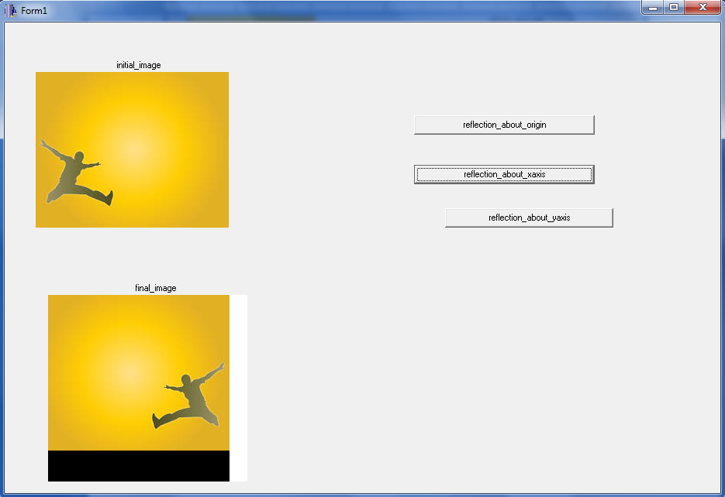

**Reflection about Y-axis:**

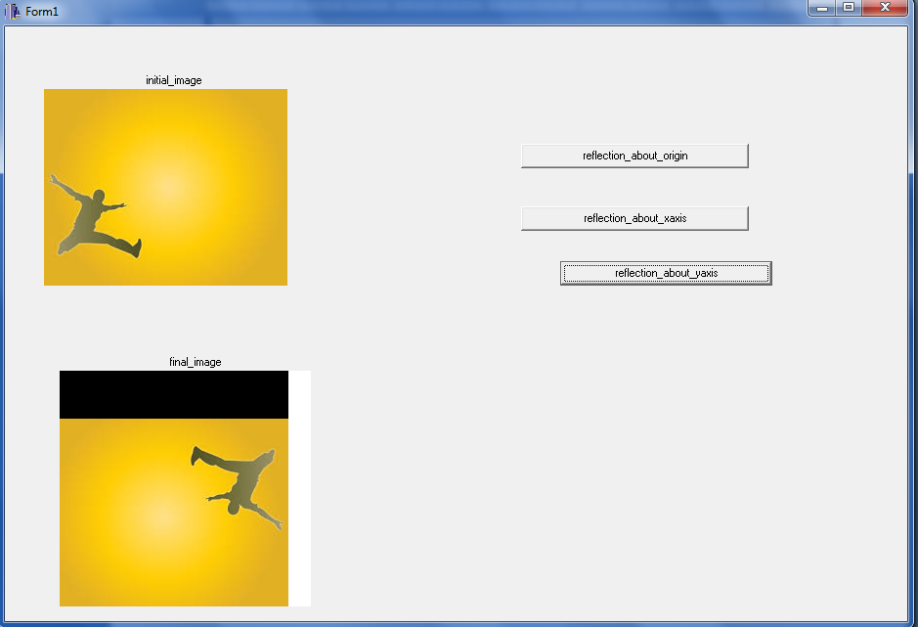

**Conclusion:**

Hence the output is obtained as a reflection of image about the origin,x-axis and y-axis.